**Assignment 1**

1. What is JDK? JRE? JVM?

JDK in Java is an abbreviation for **Java Development Kit**. It is a bundle of software development tools and supporting libraries combined with the Java Runtime Environment (JRE) and Java Virtual Machine (JVM).

The JRE consists of the Java Virtual Machine (JVM), Java platform core classes, and supporting Java platform libraries. The JRE is the runtime portion of Java software, which is all you need to run Java WebStart applications from a supported web browser.

The Java Virtual Machine defines various run-time data areas that are used during execution of a program. Some of these data areas are created on Java Virtual Machine start-up and are destroyed only when the Java Virtual Machine exits. Other data areas are per thread.

1. What is java compiler?

A Java compiler is a program that takes the text file work of a developer and compiles it into a platform-independent Java file.

1. Why is java platform independent?

Java is platform-independent because it does not depend on any type of platform.

1. What is IDE? Why is it important for developers?

An IDE, or Integrated Development Environment, enables programmers to consolidate the different aspects of writing a computer program

1. Is java case sensitive?

Java is a case-sensitive language, which means that the upper or lower case of letters in your Java programs matter.

1. What do the following key words do?  
   static, final, public, private, void, null, package, Class, new

static means that the particular member belongs to a type itself, rather than to an instance of that type.

Final in the Java programming language, the final keyword is used in several contexts to define an entity that can only be assigned once.

Public members are visible to all other classes. This means that any other class can access a public field or method

private is a Java keyword which declares a member's access as private. That is, the member is only visible within the class, not from any other class (including subclasses).

The void keyword in Java denotes that a method does not have a return type.

Null is a special literal of the null type

A package in Java is used to group related classes.

A Class is like an object constructor, or a "blueprint" for creating objects.

The Java new keyword is used to create an instance of the class.

1. What is primitive type and reference type?

primitives are data types, while references are pointers,

1. Is parameter passed by value or reference?

By value

1. What is the output: System.out.println(1 > 0 : “A”:”B”);

A

1. How to define constants in java?

static final datatype identifier_name = constant;

1. What is String? Is it primitive type?

String is an object, it isn't a primitive type at all

1. How to check if a String is representing a number?

parsing it using Java's built-in methods

1. Write a program to implement the following activity diagram:

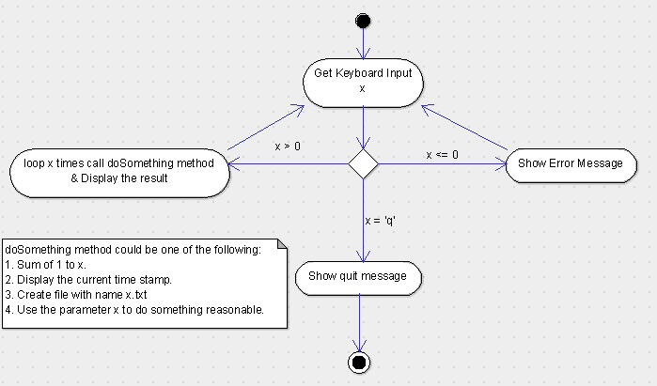

1. Write a program to merge two array of int.
2. Write a program to find the second largest number inside an array of int.